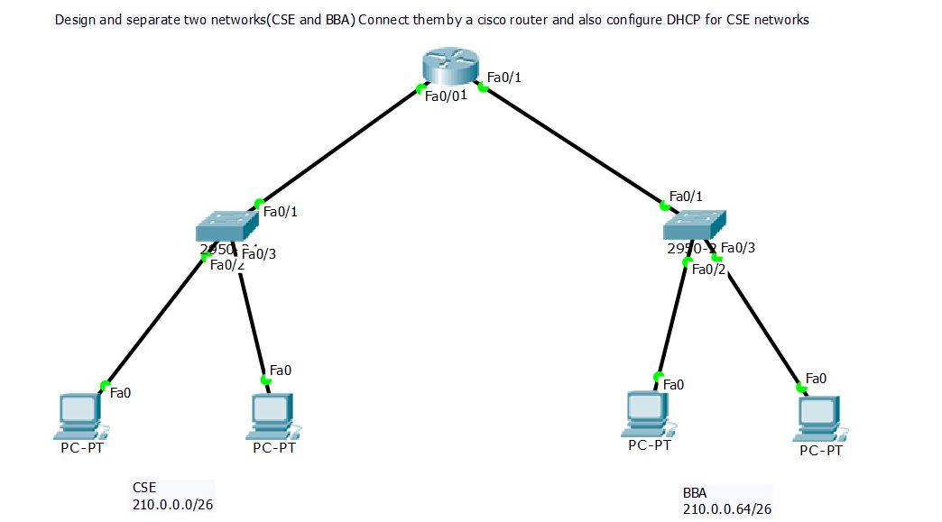

**Router**

Continue with configuration dialog? [yes/no]: no

Press RETURN to get started!

Router>en

Router#conf t

Enter configuration commands, one per line. End with CNTL/Z.

Router(config)#int fa 0/0

Router(config-if)#ip add 210.0.0.1 255.255.255.192

Router(config-if)#no shut

Router(config-if)#ex

Router(config)#ip dhcp pool CSE

Router(dhcp-config)#net 210.0.0.0 255.255.255.192

Router(dhcp-config)#default-router 210.0.0.1

Router(dhcp-config)#do wr

Router(dhcp-config)#ex

Router(config)#int fa 0/1

Router(config-if)#ip add 210.0.0.65 255.255.255.192

Router(config-if)#no shut

Router(config-if)#^Z

Router#wr